

Project Report on

“University Campus Networking”

**Course Title:** Cisco Network Administrator

**Group code:** QAL_ISS2_M1e

**Team:**

Hend Mostafa tawfik Mohamed

Yasmin AbdulMonem AbdulRahman Azab

Nashwa Eltokhy Adly Barak

Christeen Nader Melek yasa

Faiza adel emam

**Under supervision:**

Eng/Gamal E. El-Nagar

**Abstract:**

This report provides a comprehensive look at the design of the university system network, implemented through Cisco Packet Tracer, with the aim of facilitating communication between the university administration and the rest of the colleges. The primary objectives of this project revolve around formulating and implementing a robust, scalable, and forward-looking network infrastructure. A hierarchical model was used, and redundancy measures were incorporated at each layer to enhance reliability., creating wireless networks for individual departments, creating distinct VLANs and subnets, and implementing Border Gateway Protocol (BGP) for routing. Configuration details include setting up DHCP servers, assigning static IP addresses, implementing Domain Name Server (DNS), implementing E-mail server that manages the sending, receiving, and storage of email messages, implementing Secure Shell (SSH) for secure access, Configuring switchport security or Port-Security on the switches, Configuring standard and extended Access Control Lists (ACL), implementing Site-to-Site IPsec (VPN) , and Port Address Translation (NAT) for managing outbound communications, implementing access point (AP) is a term used for a network device that bridges wired and wireless networks. The report emphasizes the importance of rigorous testing and validation processes, ensuring the successful deployment of a resilient network infrastructure that not only meets current business requirements, but also positions the organization strategically for technological advancement and future expansion.

# **Background:**

Amidst the ever-evolving landscape of modern higher education, the design of a robust and scalable network infrastructure is paramount for supporting the diverse needs of a university campus. As universities expand and grow, the strategic importance of network routing and switching becomes increasingly evident. These elements play a crucial role in ensuring seamless communication, efficient data transfer, and reliable access to resources for students, faculty, staff, and administrators.

This project focuses on developing a comprehensive network design for a university campus, utilizing Cisco Packet Tracer to simulate and test various network configurations. The design will be tailored to meet the specific requirements and growth plans of the university, ensuring a reliable and efficient network that can support the demands of academic and administrative activities.

**Objectives:**

The primary objectives of a university campus network design project are to:

Establish a hierarchical network structure with redundancy at all levels.

Deploy wireless networks tailored to the specific needs of different departments and user groups.

Implement Virtual Local Area Networks (VLANs) and subnets to segregate traffic and enhance security.

Configure routing protocols, security protocols, and advanced features like SSH and PAT to optimize network performance and security.

Configure backup is primarily for network redundancy and high availability.

By achieving these objectives, a university can develop a network infrastructure that is scalable, resilient, and capable of supporting the diverse needs of students, faculty, staff, and administrators, both now and in the future.

# **Network Design**

# **Topology:**

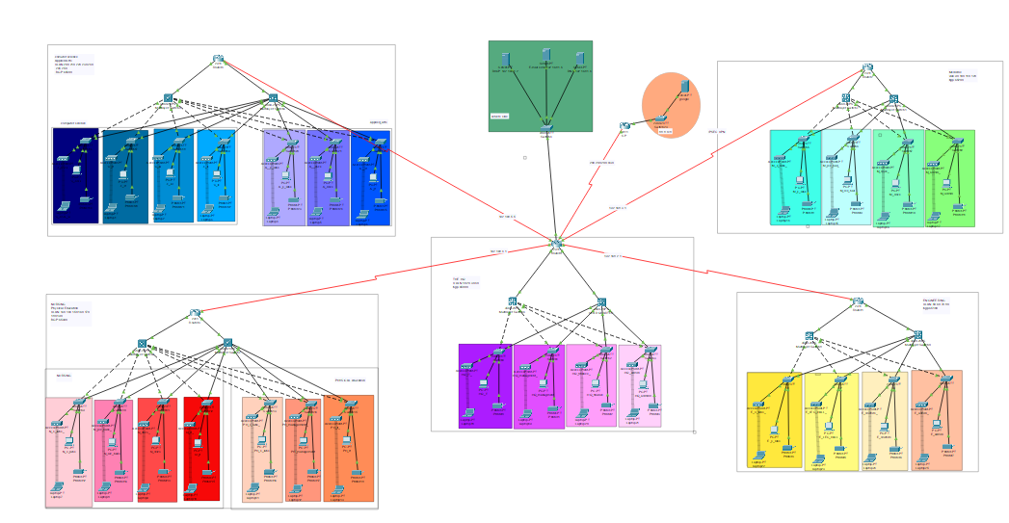

## **Components**

The network design for the project incorporates the following devices

1. Routers (6):

* HQ
* 5 routers for the colleges

1. Multilayer switches (10)
2. Layer 2 Switches (28):

* Connect individual departments to the core layer.
* Facilitate communication within respective VLANs.

1. End-User Devices (PCs, laptops, printers)
2. DHCP Servers (1):

* Located in the server room.
* Dynamically allocate IP addresses to end-user devices

1. Server Room Devices (Servers, etc.)

* DNS server, E-mail server, etc.
* Devices in the server room are allocated static IP addresses.
* These devices may include servers, storage units, and networking equipment.

1. Google server (1)

## **Addressing Table**

**Routers**

|  |  |  |  |  |
| --- | --- | --- | --- | --- |
| Device | interface | Ip Address | Subnet mask | Default gateway |
| Router 0 (HQ) | G0/0.10 | 192.168.10.1 | 255.255.255.128 | N/A |
| G0/0.20 | 192.168.20.1 | 255.255.255.128 | N/A |
| G0/0.30 | 192.168.30.1 | 255.255.255.128 | N/A |
| G0/0.40 | 192.168.40.1 | 255.255.255.128 | N/A |
| G0/1 | 192.168.1.1 | 255.255.255.0 | N/A |
| G0/2.10 | 192.168.10.129 | 255.255.255.128 | N/A |
| G0/2.20 | 192.168.20.129 | 255.255.255.128 | N/A |
| G0/2.30 | 192.168.30.129 | 255.255.255.128 | N/A |
| G0/2.40 | 192.168.40.129 | 255.255.255.128 | N/A |
| S0/0/0 | 192.168.2.1 | 255.255.255.0 | N/A |
| S0/0/1 | 192.168.3.1 | 255.255.255.0 | N/A |
| S0/1/0 | 192.168.4.1 | 255.255.255.0 | N/A |
| S0/1/1 | 192.168.5.5 | 255.255.255.0 | N/A |
| S0/2/0 | 200.200.200.2 | 255.255.255.252 | N/A |
| Router 1 (Engineering) | G0/0.50 | 192.168.50.1 | 255.255.255.128 | N/A |
| G0/0.60 | 192.168.60.1 | 255.255.255.128 | N/A |
| G0/0.70 | 192.168.70.1 | 255.255.255.128 | N/A |
| G0/0.80 | 192.168.80.1 | 255.255.255.128 | N/A |
| G0/1.50 | 192.168.50.129 | 255.255.255.128 | N/A |
| G0/1.60 | 192.168.60.129 | 255.255.255.128 | N/A |
| G0/1.70 | 192.168.70.129 | 255.255.255.128 | N/A |
| G0/1.80 | 192.168.80.129 | 255.255.255.128 | N/A |
| G0/2 | 192.168.3.1 | 255.255.255.0 | N/A |
| S0/0/0 | 192.168.2.2 | 255.255.255.0 | N/A |
| Router 2(Medicine) | G0/0.90 | 192.168.90.1 | 255.255.255.128 | N/A |
| G0/0.100 | 192.168.100.1 | 255.255.255.128 | N/A |
| G0/0.110 | 192.168.110.1 | 255.255.255.128 | N/A |
| G0/0.120 | 192.168.120.1 | 255.255.255.128 | N/A |
| G0/1.90 | 192.168.90.129 | 255.255.255.128 | N/A |
| G0/1.100 | 192.168.100.129 | 255.255.255.128 | N/A |
| G0/1.110 | 192.168.110.129 | 255.255.255.128 | N/A |
| G0/1.120 | 192.168.120.129 | 255.255.255.128 | N/A |
| S0/0/0 | 192.168.3.2 | 255.255.255.0 | N/A |
| Router 3  (Nursing &  Physical Education) | G0/0.130 | 192.168.130.1 | 255.255.255.128 | N/A |
| G0/0.140 | 192.168.140.1 | 255.255.255.128 | N/A |
| G0/0.150 | 192.168.150.1 | 255.255.255.128 | N/A |
| G0/0.160 | 192.168.160.1 | 255.255.255.128 | N/A |
| G0/0.170 | 192.168.170.1 | 255.255.255.128 | N/A |
| G0/0.180 | 192.168.180.1 | 255.255.255.128 | N/A |
| G0/0.190 | 192.168.190.1 | 255.255.255.128 | N/A |
| G0/1.130 | 192.168.130.129 | 255.255.255.128 | N/A |
| G0/1.140 | 192.168.140.129 | 255.255.255.128 | N/A |
| G0/1.150 | 192.168.150.129 | 255.255.255.128 | N/A |
| G0/1.160 | 192.168.160.129 | 255.255.255.128 | N/A |
| G0/1.170 | 192.168.170.129 | 255.255.255.128 | N/A |
| G0/1.180 | 192.168.180.129 | 255.255.255.128 | N/A |
| G0/1.190 | 192.168.190.120 | 255.255.255.128 | N/A |
| S0/0/0 | 192.168.4.2 | 255.255.255.0 | N/A |
| Router 4 (computer science & Applied Arts) | G0/0.200 | 192.168.200.1 | 255.255.255.128 | N/A |
| G0/0.210 | 192.168.210.1 | 255.255.255.128 | N/A |
| G0/0.220 | 192.168.220.1 | 255.255.255.128 | N/A |
| G0/0.230 | 192.168.230.1 | 255.255.255.128 | N/A |
| G0/0.240 | 192.168.240.1 | 255.255.255.128 | N/A |
| G0/0.245 | 192.168.245.1 | 255.255.255.128 | N/A |
| G0/0.250 | 192.168.250.1 | 255.255.255.128 | N/A |
| G0/1.200 | 192.168.200.129 | 255.255.255.128 | N/A |
| G0/1.210 | 192.168.210.129 | 255.255.255.128 | N/A |
| G0/1.220 | 192.168.220.129 | 255.255.255.128 | N/A |
| G0/1.230 | 192.168.230.129 | 255.255.255.128 | N/A |
| G0/1.240 | 192.168.240.129 | 255.255.255.128 | N/A |
| G0/1.245 | 192.168.245.129 | 255.255.255.128 | N/A |
| G0/1.250 | 192.168.250.129 | 255.255.255.128 | N/A |
| S0/0/0 | 192.168.5.1 | 255.255.255.0 | N/A |

# Routing Configuration

## Router Configuration

Basic Router Configuration

conf t # Enter global configuration mode

hostname HQ # Set the hostname for the device to "HQ"

enable password cisco # Set the enable password for privileged EXEC mode

banner motd #welcome# # Configure a message of the day (MOTD) banner

no ip domain lookup # Disable DNS lookup for unknown commands

line console 0 # Enter console line configuration mode

password cisco # Set console line password to "cisco"

login # Enable login authentication for the console

exit # Exit back to global configuration mode

login block-for 60 attempts 3 within 30 # Lock login for 60 sec if 3 failed attempts occur

service password-encryption # Encrypt all passwords in the configuration file

ip domain name cisco.net # Set the domain name of the device to "cisco.net"

username admin password cisco # Create a local user account with username "admin"

crypto key generate rsa # Generate RSA encryption keys for SSH

1024 # Set the RSA key size to 1024 bits

line vty 0 15 # Enter VTY line configuration mode for lines 0 to 15

login local # Use local user database for VTY line authentication

transport input ssh # Allow only SSH protocol for remote access

do wr # Save the running configuration to the startup conf

## **Static and Dynamic Routing**

Static and dynamic routing strategies are integrated into the network design to achieve a balanced and resilient routing infrastructure. Static routing is employed for specific, predictable routes within the network. For example, static routes are configured on routers to direct traffic to the dedicated DHCP servers in the server room, ensuring a fixed and predetermined path for critical internal communication. On the other hand, dynamic routing, specifically BGP, is implemented for adaptive and automated route selection. BGP dynamically adjusts to changes in the network, making it suitable for scalability and flexibility. This combination of static and dynamic routing provides a robust and versatile routing solution, catering to predefined and evolving routing needs within the "University Campus Networking" project.

**BGP on Routers R0, R1, R2, R3 and R4**

**HQ router (R0):**

Router(config)# router bgp 65000

Router(config-router)# network 192.168.10.0 mask 255.255.255.0

Router(config-router)# network 192.168.20.0 mask 255.255.255.0

Router(config-router)# network 192.168.30.0 mask 255.255.255.0

Router(config-router)# network 192.168.40.0 mask 255.255.255.0

Router(config-router)# network 192.168.1.0 mask 255.255.255.0

Router(config-router)# network 192.168.6.0 mask 255.255.255.0

Router(config-router)# network 200.200.200.0 mask 255.255.255.254

Router(config-router)# neighbor 192.168.2.2 remote-as 65100

Router(config-router)# neighbor 192.168.3.2 remote-as 65200

Router(config-router)# neighbor 192.168.4.2 remote-as 65300

Router(config-router)# neighbor 192.168.5.1 remote-as 65400

Router(config-router)# neighbor 200.200.200.1 remote-as 65010

**Engineering router(R1)**

Router(config)# router bgp 65100

Router(config-router)# network 192.168.50.0 mask 255.255.255.0

Router(config-router)# network 192.168.60.0 mask 255.255.255.0

Router(config-router)# network 192.168.70.0 mask 255.255.255.0

Router(config-router)# network 192.168.80.0 mask 255.255.255.0

Router(config-router)# neighbor 192.168.2.1 remote-as 65000

**Medicine router (R2)**

Router(config)# router bgp 65200

Router(config-router)# network 192.168.90.0 mask 255.255.255.0

Router(config-router)# network 192.168.100.0 mask 255.255.255.0

Router(config-router)# network 192.168.110.0 mask 255.255.255.0

Router(config-router)# network 192.168.120.0 mask 255.255.255.0

Router(config-router)# neighbor 192.168.3.1 remote-as 65000

**Nursing & Education router(R3)**

Router(config)# router bgp 65300

Router(config-router)# network 192.168.130.0 mask 255.255.255.0

Router(config-router)# network 192.168.140.0 mask 255.255.255.0

Router(config-router)# network 192.168.150.0 mask 255.255.255.0

Router(config-router)# network 192.168.160.0 mask 255.255.255.0

Router(config-router)# network 192.168.170.0 mask 255.255.255.0

Router(config-router)# network 192.168.180.0 mask 255.255.255.0

Router(config-router)# network 192.168.190.0 mask 255.255.255.0

Router(config-router)# neighbor 192.168.4.1 remote-as 65000

**Computer Science & Applied Arts router(R4)**

Router(config)# router bgp 65400

Router(config-router)# network 192.168.200.0 mask 255.255.255.0

Router(config-router)# network 192.168.210.0 mask 255.255.255.0

Router(config-router)# network 192.168.220.0 mask 255.255.255.0

Router(config-router)# network 192.168.230.0 mask 255.255.255.0

Router(config-router)# network 192.168.240.0 mask 255.255.255.0

Router(config-router)# network 192.168.245.0 mask 255.255.255.0

Router(config-router)# network 192.168.250.0 mask 255.255.255.0

Router(config-router)# neighbor 192.168.5.5 remote-as 65000

# Switching Configuration

## Switch Configuration

Basic SW configuration

hostname Google

enable password cisco

banner motd #welcome#

no ip domain lookup

line console 0

password cisco

login

exit

service password-encryption

do wr

## **VLAN and Inter-VLAN Routing**

Virtual LANs (VLANs) are utilized to logically segment the network into separate broadcast domains, enhancing both security and efficiency. In this project, VLANs ranging from VLAN 10 to VLAN 250 are used to isolate different departments, including Student Labs (S_Labs), Lecture Halls (Lec_Hall), and Administration or IT. Each VLAN is given a specific name and mapped to designated switch ports using the `switchport access vlan` command. This approach not only reduces broadcast traffic but also improves network management. VLAN configurations are applied on individual switches to ensure a secure and well-structured network infrastructure. Additionally, inter-VLAN routing is enabled using Layer 3 switches to facilitate communication between different VLANs.

VLAN Configuration

**HQ Building**

**Multilayer Switch 0**

Switch>enable

Switch# config terminal

Switch(config)#vlan 10

Switch(config-vlan)#name IT

Switch(config-vlan)#exit

Switch(config)#int f0/1

Switch(config-if)#switchport mode access

Switch(config-if)#switchport access vlan 10

Switch(config-if)#exit

Switch(config)#vlan 20

Switch(config-vlan)#name management

Switch(config-vlan)#exit

Switch(config)#int f0/7

Switch(config-if)#switchport mode access

Switch(config-if)#switchport access vlan 20

Switch(config-if)#exit

Switch(config)#vlan 30

Switch(config-vlan)#name finance

Switch(config-vlan)#exit

Switch(config)#int f0/13

Switch(config-if)#switchport mode access

Switch(config-if)#switchport access vlan 30

Switch(config-if)#exit

Switch(config)#vlan 40

Switch(config-vlan)#name admin

Switch(config-vlan)#exit

Switch(config)#int f0/24

Switch(config-if)#switchport mode access

Switch(config-if)#switchport access vlan 40

Switch(config-if)#exit

Switch(config)#vlan 99

Switch(config-vlan)#name vlan99

Switch(config-vlan)#exit

Switch(config)#int G0/1

Switch(config-if)# switchport trunk encapsulation dot1q

Switch(config-if)# switchport trunk allowed vlan 10,20,30,40,99

Switch(config-if)#exit

**Multilayer Switch 1 (Redundancy)**

Switch>enable

Switch# config terminal

Switch(config)#vlan 1

Switch(config-vlan)#name VLAN0010

Switch(config-vlan)#exit

Switch(config)#int f0/2

Switch(config-if)#switchport mode access

Switch(config-if)#switchport access vlan 10

Switch(config-if)#exit

Switch(config)#vlan 20

Switch(config-vlan)#name VLAN0020

Switch(config-vlan)#exit

Switch(config)#int f0/3

Switch(config-if)#switchport mode access

Switch(config-if)#switchport access vlan 20

Switch(config-if)#exit

Switch(config)#vlan 30

Switch(config-vlan)#name VLAN0030

Switch(config-vlan)#exit

Switch(config)#int f0/4

Switch(config-if)#switchport mode access

Switch(config-if)#switchport access vlan 30

Switch(config-if)#exit

Switch(config)#vlan 40

Switch(config-vlan)#name VLAN0040

Switch(config-vlan)#exit

Switch(config)#int f0/5

Switch(config-if)#switchport mode access

Switch(config-if)#switchport access vlan 40

Switch(config-if)#exit

Switch(config)#vlan 99

Switch(config-vlan)#exit

Switch(config)#int f0/1

Switch(config-if)# switchport trunk encapsulation dot1q

Switch(config-if)# switchport trunk allowed vlan 10,20,30,40,99

Switch(config-if)#exit

**Layer 2 Switch 1**

Switch>enable

Switch# config terminal

Switch(config)#vlan 10

Switch(config-vlan)#name IT

Switch(config-vlan)#exit

Switch(config)#interface range fa0/1-24

Switch(config-if-range)# switchport mode access

Switch(config-if-range)# switchport access vlan 10

Switch(config-if-range)#exit

**Layer 2 Switch 2**

Switch>enable

Switch# config terminal

Switch(config)#vlan 20

Switch(config-vlan)#name management

Switch(config-vlan)#exit

Switch(config)#interface range fa0/1-24

Switch(config-if-range)# switchport mode access

Switch(config-if-range)# switchport access vlan 20

Switch(config-if-range)#exit

**Layer 2 Switch 3**

Switch>enable

Switch# config terminal

Switch(config)#vlan 30

Switch(config-vlan)#name finance

Switch(config-vlan)#exit

Switch(config)#interface range fa0/1-24

Switch(config-if-range)# switchport mode access

Switch(config-if-range)# switchport access vlan 30

Switch(config-if-range)#exit

**Layer 2 Switch 4**

Switch>enable

Switch# config terminal

Switch(config)#vlan 40

Switch(config-vlan)#name admin

Switch(config-vlan)#exit

Switch(config)#interface range fa0/1-24

Switch(config-if-range)# switchport mode access

Switch(config-if-range)# switchport access vlan 40

Switch(config-if-range)#exit

**Faculty of Engineering Building:**

**Multilayer Switch 2**

Switch>enable

Switch# config terminal

Switch(config)#vlan 50

Switch(config-vlan)#name E_s_labs

Switch(config-vlan)#exit

Switch(config)#int f0/1

Switch(config-if)#switchport mode access

Switch(config-if)#switchport access vlan 50

Switch(config-if)#exit

Switch(config)#vlan 60

Switch(config-vlan)#name E_LEC_HALL

Switch(config-vlan)#exit

Switch(config)#int f0/2

Switch(config-if)#switchport mode access

Switch(config-if)#switchport access vlan 60

Switch(config-if)#exit

Switch(config)#vlan 70

Switch(config-vlan)#name E_docs

Switch(config-vlan)#exit

Switch(config)#int f0/3

Switch(config-if)#switchport mode access

Switch(config-if)#switchport access vlan 70

Switch(config-if)#exit

Switch(config)#vlan 80

Switch(config-vlan)#name E_admin

Switch(config-vlan)#exit

Switch(config)#int f0/4

Switch(config-if)#switchport mode access

Switch(config-if)#switchport access vlan 80

Switch(config-if)#exit

Switch(config)#vlan 99

Switch(config-vlan)#name vlan99

Switch(config-vlan)#exit

Switch(config)#int G0/1

Switch(config-if)# switchport trunk encapsulation dot1q

Switch(config-if)# switchport trunk allowed vlan 50,60,70,80,99

Switch(config-if)#exit

**Multilayer Switch 3 (Redundancy)**

Switch>enable

Switch# config terminal

Switch(config)#vlan 50

Switch(config-vlan)#name VLAN0050

Switch(config-vlan)#exit

Switch(config)#int f0/2

Switch(config-if)#switchport mode access

Switch(config-if)#switchport access vlan 50

Switch(config-if)#exit

Switch(config)#vlan 60

Switch(config-vlan)#name VLAN0060

Switch(config-vlan)#exit

Switch(config)#int f0/3

Switch(config-if)#switchport mode access

Switch(config-if)#switchport access vlan 60

Switch(config-if)#exit

Switch(config)#vlan 70

Switch(config-vlan)#name VLAN0070

Switch(config-vlan)#exit

Switch(config)#int f0/4

Switch(config-if)#switchport mode access

Switch(config-if)#switchport access vlan 70

Switch(config-if)#exit

Switch(config)#vlan 80

Switch(config-vlan)#name VLAN0080

Switch(config-vlan)#exit

Switch(config)#int f0/5

Switch(config-if)#switchport mode access

Switch(config-if)#switchport access vlan 80

Switch(config-if)#exit

Switch(config)#vlan 99

Switch(config-vlan)#name vlan99

Switch(config-vlan)#exit

Switch(config)# int f0/1

Switch(config-if)# switchport trunk encapsulation dot1q

Switch(config-if)# switchport trunk allowed vlan 50,60,70,80,99

Switch(config-if)#exit

**Layer 2 Switch 5**

Switch>enable

Switch# config terminal

Switch(config)#vlan 50

Switch(config-vlan)#name name E_s_labs

Switch(config-vlan)#exit

Switch(config)#interface range fa0/1-24

Switch(config-if-range)# switchport mode access

Switch(config-if-range)# switchport access vlan 50

Switch(config-if-range)#exit

**Layer 2 Switch 6**

Switch>enable

Switch# config terminal

Switch(config)#vlan 60

Switch(config-vlan)#name name E_lec_Hall

Switch(config-vlan)#exit

Switch(config)#interface range fa0/1-24

Switch(config-if-range)# switchport mode access

Switch(config-if-range)# switchport access vlan 60

Switch(config-if-range)#exit

**Layer 2 Switch 7**

Switch>enable

Switch# config terminal

Switch(config)#vlan 70

Switch(config-vlan)#name name E_Docs

Switch(config-vlan)#exit

Switch(config)#interface range fa0/1-24

Switch(config-if-range)# switchport mode access

Switch(config-if-range)# switchport access vlan 70

Switch(config-if-range)#exit

**Layer 2 Switch 8**

Switch>enable

Switch# config terminal

Switch(config)#vlan 80

Switch(config-vlan)#name name E_admin

Switch(config-vlan)#exit

Switch(config)#interface range fa0/1-24

Switch(config-if-range)# switchport mode access

Switch(config-if-range)# switchport access vlan 80

Switch(config-if-range)#exit

**Faculty of Medicine Building:**

**Multilayer Switch 4**

Switch>enable

Switch# config terminal

Switch(config)#vlan 90

Switch(config-vlan)#name M_s_labs

Switch(config-vlan)#exit

Switch(config)#int f0/1

Switch(config-if)#switchport mode access

Switch(config-if)#switchport access vlan 90

Switch(config-if)#exit

Switch(config)#vlan 100

Switch(config-vlan)#name M_LEC_HALL

Switch(config-vlan)#exit

Switch(config)#int f0/2

Switch(config-if)#switchport mode access

Switch(config-if)#switchport access vlan 100

Switch(config-if)#exit

Switch(config)#vlan 110

Switch(config-vlan)#name M_docs

Switch(config-vlan)#exit

Switch(config)#int f0/3

Switch(config-if)#switchport mode access

Switch(config-if)#switchport access vlan 110

Switch(config-if)#exit

Switch(config)#vlan 120

Switch(config-vlan)#name M_admin

Switch(config-vlan)#exit

Switch(config)#int f0/4

Switch(config-if)#switchport mode access

Switch(config-if)#switchport access vlan 120

Switch(config-if)#exit

Switch(config)#vlan 99

Switch(config-vlan)#name vlan99

Switch(config-vlan)#exit

Switch(config)#int G0/1

Switch(config-if)# switchport trunk encapsulation dot1q

Switch(config-if)# switchport trunk allowed vlan 90, 99,100,110,120

Switch(config-if)#exit

**Multilayer Switch 5 (Redundancy)**

Switch>enable

Switch# config terminal

Switch(config)#vlan 90

Switch(config-vlan)#name VLAN0090

Switch(config-vlan)#exit

Switch(config)#int f0/2

Switch(config-if)#switchport mode access

Switch(config-if)#switchport access vlan 90

Switch(config-if)#exit

Switch(config)#vlan 100

Switch(config-vlan)#name VLAN0100

Switch(config-vlan)#exit

Switch(config)#int f0/3

Switch(config-if)#switchport mode access

Switch(config-if)#switchport access vlan 100

Switch(config-if)#exit

Switch(config)#vlan 110

Switch(config-vlan)#name VLAN0110

Switch(config-vlan)#exit

Switch(config)#int f0/4

Switch(config-if)#switchport mode access

Switch(config-if)#switchport access vlan 110

Switch(config-if)#exit

Switch(config)#vlan 120

Switch(config-vlan)#name VLAN0120

Switch(config-vlan)#exit

Switch(config)#int f0/5

Switch(config-if)#switchport mode access

Switch(config-if)#switchport access vlan 120

Switch(config-if)#exit

Switch(config)#vlan 99

Switch(config-vlan)#name vlan99

Switch(config-vlan)#exit

Switch(config)# int f0/1

Switch(config-if)# switchport trunk encapsulation dot1q

Switch(config-if)# switchport trunk allowed vlan 90, 99,100,110,120

Switch(config-if)#exit

**Layer 2 Switch 9**

Switch>enable

Switch# config terminal

Switch(config)#vlan 90

Switch(config-vlan)#name M_s_labs

Switch(config-vlan)#exit

Switch(config)#interface range fa0/1-24

Switch(config-if-range)# switchport mode access

Switch(config-if-range)# switchport access vlan 90

Switch(config-if-range)#exit

**Layer 2 Switch 10**

Switch>enable

Switch# config terminal

Switch(config)#vlan 100

Switch(config-vlan)#name M_lec_hall

Switch(config-vlan)#exit

Switch(config)#interface range fa0/1-24

Switch(config-if-range)# switchport mode access

Switch(config-if-range)# switchport access vlan 100

Switch(config-if-range)#exit

**Layer 2 Switch 11**

Switch>enable

Switch# config terminal

Switch(config)#vlan 110

Switch(config-vlan)#name M_docs

Switch(config-vlan)#exit

Switch(config)#interface range fa0/1-24

Switch(config-if-range)# switchport mode access

Switch(config-if-range)# switchport access vlan 110

Switch(config-if-range)#exit

**Layer 2 Switch 12**

Switch>enable

Switch# config terminal

Switch(config)#vlan 120

Switch(config-vlan)#name M_admin

Switch(config-vlan)#exit

Switch(config)#interface range fa0/1-24

Switch(config-if-range)# switchport mode access

Switch(config-if-range)# switchport access vlan 120

Switch(config-if-range)#exit

**Faculty of Nursing & Faculty of Physical.E Building:**

**Multilayer Switch 6**

Switch>enable

Switch# config terminal

Switch(config)#vlan 130

Switch(config-vlan)#name N_s_labs

Switch(config-vlan)#exit

Switch(config)#int f0/1

Switch(config-if)#switchport mode access

Switch(config-if)#switchport access vlan 130

Switch(config-if)#exit

Switch(config)#vlan 140

Switch(config-vlan)#name N_LEC_HALL

Switch(config-vlan)#exit

Switch(config)#int f0/2

Switch(config-if)#switchport mode access

Switch(config-if)#switchport access vlan 140

Switch(config-if)#exit

Switch(config)#vlan 150

Switch(config-vlan)#name N_docs

Switch(config-vlan)#exit

Switch(config)#int f0/3

Switch(config-if)#switchport mode access

Switch(config-if)#switchport access vlan 150

Switch(config-if)#exit

Switch(config)#vlan 160

Switch(config-vlan)#name N_it

Switch(config-vlan)#exit

Switch(config)#int f0/4

Switch(config-if)#switchport mode access

Switch(config-if)#switchport access vlan 160

Switch(config-if)#exit

Switch(config)#vlan 170

Switch(config-vlan)#name PH_s_labs

Switch(config-vlan)#exit

Switch(config)#int f0/5

Switch(config-if)#switchport mode access

Switch(config-if)#switchport access vlan 170

Switch(config-if)#exit

Switch(config)#vlan 180

Switch(config-vlan)#name PH_management

Switch(config-vlan)#exit

Switch(config)#int f0/6

Switch(config-if)#switchport mode access

Switch(config-if)#switchport access vlan 180

Switch(config-if)#exit

Switch(config)#vlan 190

Switch(config-vlan)#name PH_it

Switch(config-vlan)#exit

Switch(config)#int f0/7

Switch(config-if)#switchport mode access

Switch(config-if)#switchport access vlan 190

Switch(config-if)#exit

Switch(config)#vlan 99

Switch(config-vlan)#name vlan99

Switch(config-vlan)#exit

Switch(config)#int G0/1

Switch(config-if)# switchport trunk encapsulation dot1q

Switch(config-if)# switchport trunk allowed vlan 99,130,140,150,160,170,180,190

Switch(config-if)#exit

**Multilayer Switch 7 (Redundancy)**

Switch>enable

Switch# config terminal

Switch(config)#vlan 130

Switch(config-vlan)#name VLAN0130

Switch(config-vlan)#exit

Switch(config)#int f0/1

Switch(config-if)#switchport mode access

Switch(config-if)#switchport access vlan 130

Switch(config-if)#exit

Switch(config)#vlan 140

Switch(config-vlan)#name VLAN0140

Switch(config-vlan)#exit

Switch(config)#int f0/2

Switch(config-if)#switchport mode access

Switch(config-if)#switchport access vlan 140

Switch(config-if)#exit

Switch(config)#vlan 150

Switch(config-vlan)#name VLAN0150

Switch(config-vlan)#exit

Switch(config)#int f0/3

Switch(config-if)#switchport mode access

Switch(config-if)#switchport access vlan 150

Switch(config-if)#exit

Switch(config)#vlan 160

Switch(config-vlan)#name VLAN0160

Switch(config-vlan)#exit

Switch(config)#int f0/4

Switch(config-if)#switchport mode access

Switch(config-if)#switchport access vlan 160

Switch(config-if)#exit

Switch(config)#vlan 170

Switch(config-vlan)#name VLAN0170

Switch(config-vlan)#exit

Switch(config)#int f0/5

Switch(config-if)#switchport mode access

Switch(config-if)#switchport access vlan 170

Switch(config-if)#exit

Switch(config)#vlan 180

Switch(config-vlan)#name VLAN0180

Switch(config-vlan)#exit

Switch(config)#int f0/6

Switch(config-if)#switchport mode access

Switch(config-if)#switchport access vlan 180

Switch(config-if)#exit

Switch(config)#vlan 190

Switch(config-vlan)#name VLAN0190

Switch(config-vlan)#exit

Switch(config)#int f0/7

Switch(config-if)#switchport mode access

Switch(config-if)#switchport access vlan 190

Switch(config-if)#exit

Switch(config)#vlan 99

Switch(config-vlan)#name vlan99

Switch(config-vlan)#exit

Switch(config)#int F0/8

Switch(config-if)# switchport trunk encapsulation dot1q

Switch(config-if)# switchport trunk allowed vlan 99,130,140,150,160,170,180,190

Switch(config-if)#exit

**Layer 2 Switch 13**

Switch>enable

Switch# config terminal

Switch(config)#vlan 130

Switch(config-vlan)#name N_s_labs

Switch(config-vlan)#exit

Switch(config)#interface range fa0/1-24

Switch(config-if-range)# switchport mode access

Switch(config-if-range)# switchport access vlan 130

Switch(config-if-range)#exit

**Layer 2 Switch 14**

Switch>enable

Switch# config terminal

Switch(config)#vlan 140

Switch(config-vlan)#name N_lec_hall

Switch(config-vlan)#exit

Switch(config)#interface range fa0/1-24

Switch(config-if-range)# switchport mode access

Switch(config-if-range)# switchport access vlan 140

Switch(config-if-range)#exit

**Layer 2 Switch 15**

Switch>enable

Switch# config terminal

Switch(config)#vlan 150

Switch(config-vlan)#name N_docs

Switch(config-vlan)#exit

Switch(config)#interface range fa0/1-24

Switch(config-if-range)# switchport mode access

Switch(config-if-range)# switchport access vlan 150

Switch(config-if-range)#exit

**Layer 2 Switch 16**

Switch>enable

Switch# config terminal

Switch(config)#vlan 160

Switch(config-vlan)#name N_it

Switch(config-vlan)#exit

Switch(config)#interface range fa0/1-24

Switch(config-if-range)# switchport mode access

Switch(config-if-range)# switchport access vlan 160

Switch(config-if-range)#exit

**Layer 2 Switch 17:**

Switch>enable

Switch# config terminal

Switch(config)#vlan 170

Switch(config-vlan)#name PH_s_labs

Switch(config-vlan)#exit

Switch(config)#interface range fa0/1-24

Switch(config-if-range)# switchport mode access

Switch(config-if-range)# switchport access vlan 170

Switch(config-if-range)#exit

**Layer 2 Switch 18**

Switch>enable

Switch# config terminal

Switch(config)#vlan 180

Switch(config-vlan)#name PH_management

Switch(config-vlan)#exit

Switch(config)#interface range fa0/1-24

Switch(config-if-range)# switchport mode access

Switch(config-if-range)# switchport access vlan 180

Switch(config-if-range)#exit

**Layer 2 Switch 19:**

Switch>enable

Switch# config terminal

Switch(config)#vlan 190

Switch(config-vlan)#name PH_it

Switch(config-vlan)#exit

Switch(config)#interface range fa0/1-24

Switch(config-if-range)# switchport mode access

Switch(config-if-range)# switchport access vlan 190

Switch(config-if-range)#exit

**Faculty of Computer science & Applied Arts Building:**

**Multilayer Switch 8**

Switch>enable

Switch# config terminal

Switch(config)#vlan 200

Switch(config-vlan)#name C_docs

Switch(config-vlan)#exit

Switch(config)#int f0/1

Switch(config-if)#switchport mode access

Switch(config-if)#switchport access vlan 200

Switch(config-if)#exit

Switch(config)#vlan 210

Switch(config-vlan)#name C_it

Switch(config-vlan)#exit

Switch(config)#int f0/2

Switch(config-if)#switchport mode access

Switch(config-if)#switchport access vlan 210

Switch(config-if)#exit

Switch(config)#vlan 220

Switch(config-vlan)#name C_ai

Switch(config-vlan)#exit

Switch(config)#int f0/3

Switch(config-if)#switchport mode access

Switch(config-if)#switchport access vlan 220

Switch(config-if)#exit

Switch(config)#vlan 230

Switch(config-vlan)#name C_is

Switch(config-vlan)#exit

Switch(config)#int f0/4

Switch(config-if)#switchport mode access

Switch(config-if)#switchport access vlan 230

Switch(config-if)#exit

Switch(config)#vlan 240

Switch(config-vlan)#name A_s_labs

Switch(config-vlan)#exit

Switch(config)#int f0/5

Switch(config-if)#switchport mode access

Switch(config-if)#switchport access vlan 240

Switch(config-if)#exit

Switch(config)#vlan 245

Switch(config-vlan)#name A_docs

Switch(config-vlan)#exit

Switch(config)#int f0/6

Switch(config-if)#switchport mode access

Switch(config-if)#switchport access vlan 245

Switch(config-if)#exit

Switch(config)#vlan 250

Switch(config-vlan)#name A_it

Switch(config-vlan)#exit

Switch(config)#int f0/7

Switch(config-if)#switchport mode access

Switch(config-if)#switchport access vlan 250

Switch(config-if)#exit

Switch(config)#vlan 99

Switch(config-vlan)#name vlan99

Switch(config-vlan)#exit

Switch(config)#int G0/1

Switch(config-if)# switchport trunk encapsulation dot1q

Switch(config-if)# switchport trunk allowed vlan 99,200,210,220,230,240,245,250

Switch(config-if)#exit

**Multilayer Switch 9 (Redundancy)**

Switch>enable

Switch# config terminal

Switch(config)#vlan 200

Switch(config-vlan)#name VLAN0200

Switch(config-vlan)#exit

Switch(config)#int f0/2

Switch(config-if)#switchport mode access

Switch(config-if)#switchport access vlan 200

Switch(config-if)#exit

Switch(config)#vlan 210

Switch(config-vlan)#name VLAN0210

Switch(config-vlan)#exit

Switch(config)#int f0/3

Switch(config-if)#switchport mode access

Switch(config-if)#switchport access vlan 210

Switch(config-if)#exit

Switch(config)#vlan 220

Switch(config-vlan)#name VLAN0220

Switch(config-vlan)#exit

Switch(config)#int f0/4

Switch(config-if)#switchport mode access

Switch(config-if)#switchport access vlan 220

Switch(config-if)#exit

Switch(config)#vlan 230

Switch(config-vlan)#name VLAN0230

Switch(config-vlan)#exit

Switch(config)#int f0/5

Switch(config-if)#switchport mode access

Switch(config-if)#switchport access vlan 230

Switch(config-if)#exit

Switch(config)#vlan 240

Switch(config-vlan)#name VLAN0240

Switch(config-vlan)#exit

Switch(config)#int f0/6

Switch(config-if)#switchport mode access

Switch(config-if)#switchport access vlan 240

Switch(config-if)#exit

Switch(config)#vlan 245

Switch(config-vlan)#name VLAN0245

Switch(config-vlan)#exit

Switch(config)#int f0/7

Switch(config-if)#switchport mode access

Switch(config-if)#switchport access vlan 245

Switch(config-if)#exit

Switch(config)#vlan 250

Switch(config-vlan)#name VLAN0250

Switch(config-vlan)#exit

Switch(config)#int f0/8

Switch(config-if)#switchport mode access

Switch(config-if)#switchport access vlan 250

Switch(config-if)#exit

Switch(config)#vlan 99

Switch(config-vlan)#name vlan99

Switch(config-vlan)#exit

Switch(config)#int F0/1

Switch(config-if)# switchport trunk encapsulation dot1q

Switch(config-if)# switchport trunk allowed vlan 99,200,210,220,230,240,245,250

Switch(config-if)#exit

**Layer 2 Switch 20:**

Switch>enable

Switch# config terminal

Switch(config)#vlan 200

Switch(config-vlan)#name C _docs

Switch(config-vlan)#exit

Switch(config)#interface range fa0/1-24

Switch(config-if-range)# switchport mode access

Switch(config-if-range)# switchport access vlan 200

Switch(config-if-range)#exit

**Layer 2 Switch 21:**

Switch>enable

Switch# config terminal

Switch(config)#vlan 210

Switch(config-vlan)#name C _it

Switch(config-vlan)#exit

Switch(config)#interface range fa0/1-24

Switch(config-if-range)# switchport mode access

Switch(config-if-range)# switchport access vlan 210

Switch(config-if-range)#exit

**Layer 2 Switch 22:**

Switch>enable

Switch# config terminal

Switch(config)#vlan 220

Switch(config-vlan)#name C _ai

Vlans Network

|  |  |  |
| --- | --- | --- |
| Vlan | Network | Department |
| Vlan10 | 192.168.10.0 | HQ_it |
| Vlan20 | 192.168.20.0 | HQ_management |
| Vlan30 | 192.168.30.0 | HQ_finance |
| Vlan40 | 192.168.40.0 | HQ_admin |
| Vlan50 | 192.168.50.0 | E_s_labs |
| Vlan60 | 192.168.60.0 | E_lec_hall |
| Vlan70 | 192.168.70.0 | E_doctors |
| Vlan80 | 192.168.80.0 | E_admin |
| Vlan90 | 192.168.90.0 | M_s_labs |
| Vlan100 | 192.168.100.0 | M_lec_hall |
| Vlan110 | 192.168.110.0 | M_doctors |
| Vlan120 | 192.168.120.0 | M_admin |
| Vlan130 | 192.168.130.0 | N_s_labs |
| Vlan140 | 192.168.140.0 | N_lec_hall |
| Vlan150 | 192.168.150.0 | N_doctors |
| Vlan160 | 192.168.160.0 | N_it |
| Vlan170 | 192.168.170.0 | PH_s_labs |
| Vlan180 | 192.168.180.0 | PH_management |
| Vlan190 | 192.168.190.0 | PH_it |
| Vlan200 | 192.168.200.0 | C_it |
| Vlan210 | 192.168.210.0 | C_docs |
| Vlan220 | 192.168.220.0 | C_ai |
| Vlan230 | 192.168.230.0 | C_is |
| Vlan240 | 192.168.240.0 | A_s_labs |
| Vlan245 | 192.168.245.0 | A_lec_hall |
| Vlan250 | 192.168.250.0 | A_doctors |

# Security Measures

## PAT

Port Address Translation (PAT) is a technique used in networking to map private IP addresses within a local network to a single public IP address. This process allows multiple devices on a private network to access external networks, such as the internet, using one public IP address.

**PAT to map private IPs to a single public IP**

HQ(config)#int g0/0.10

HQ(config-subif)#ip nat inside

HQ(config-subif)#int g0/0.20

HQ(config-subif)#ip nat inside

HQ(config-subif)#int g0/0.30

HQ(config-subif)#ip nat inside

HQ(config-subif)#int g0/0.40

HQ(config-subif)#ip nat inside

HQ(config-subif)#ex

HQ(config)#int g0/2.10

HQ(config-subif)#ip nat inside

HQ(config-subif)#int g0/2.20

HQ(config-subif)#ip nat inside

HQ(config-subif)#int g0/2.30

HQ(config-subif)#ip nat inside

HQ(config-subif)#int g0/2.40

HQ(config-subif)#ip nat inside

HQ(config-subif)#ex

HQ(config)#int g0/1

HQ(config-if)#ip nat inside

HQ(config-if)#ex

HQ(config)#int s0/0/0

HQ(config-if)#ip nat inside

HQ(config-if)#ex

HQ(config)#int s0/0/1

HQ(config-if)#ip nat inside

HQ(config-if)#ex

HQ(config)#int s0/1/0

HQ(config-if)#ip nat inside

HQ(config-if)#ex

HQ(config)#int s0/1/1

HQ(config-if)#ip nat inside

HQ(config-if)#ex

HQ(config)#int s0/2/0

HQ(config-if)#ip nat outside

HQ(config-if)#ex

HQ(config)#access-list 1 permit 192.168.10.0 0.0.0.255

HQ(config)#access-list 1 permit 192.168.20.0 0.0.0.255

HQ(config)#access-list 1 permit 192.168.30.0 0.0.0.255

HQ(config)#access-list 1 permit 192.168.40.0 0.0.0.255

HQ(config)#access-list 1 permit 192.168.50.0 0.0.0.255

HQ(config)#access-list 1 permit 192.168.60.0 0.0.0.255

HQ(config)#access-list 1 permit 192.168.70.0 0.0.0.255

HQ(config)#access-list 1 permit 192.168.80.0 0.0.0.255

HQ(config)#access-list 1 permit 192.168.90.0 0.0.0.255

HQ(config)#access-list 1 permit 192.168.100.0 0.0.0.255

HQ(config)#access-list 1 permit 192.168.110.0 0.0.0.255

HQ(config)#access-list 1 permit 192.168.120.0 0.0.0.255

HQ(config)#access-list 1 permit 192.168.130.0 0.0.0.255

HQ(config)#access-list 1 permit 192.168.140.0 0.0.0.255

HQ(config)#access-list 1 permit 192.168.150.0 0.0.0.255

HQ(config)#access-list 1 permit 192.168.160.0 0.0.0.255

HQ(config)#access-list 1 permit 192.168.170.0 0.0.0.255

HQ(config)#access-list 1 permit 192.168.180.0 0.0.0.255

HQ(config)#access-list 1 permit 192.168.190.0 0.0.0.255

HQ(config)#access-list 1 permit 192.168.200.0 0.0.0.255

HQ(config)#access-list 1 permit 192.168.210.0 0.0.0.255

HQ(config)#access-list 1 permit 192.168.220.0 0.0.0.255

HQ(config)#access-list 1 permit 192.168.230.0 0.0.0.255

HQ(config)#access-list 1 permit 192.168.240.0 0.0.0.255

HQ(config)#access-list 1 permit 192.168.245.0 0.0.0.255

HQ(config)#access-list 1 permit 192.168.250.0 0.0.0.255

HQ(config)#ip nat inside source list 1 int s0/2/0 overload

## Port Security

Applying switch port security in the server room is a crucial step in safeguarding the network infrastructure. By restricting access to the servers and other critical devices, we can significantly reduce the risk of unauthorized access and potential security breaches.port security for the switch server.

**port security for server switch**

Switch(config)# interface GigabitEthernet0/1-24

Switch(config-if)# switchport port-security maximum 1

Switch(config-if)# switchport port-security mac-address sticky

Switch(config-if)# switchport port-security violation shutdown

Switch# copy running-config startup-config

## VPN

A Site-to-Site IPsec VPN is a crucial tool for securely connecting a medicine branch to its headquarters, especially in the healthcare industry where data privacy and security are paramount.

Update the router

license boot module c2900 technology-package securityk9 # Enable the Security (securityk9) technology package license on the Cisco 2900 series router, allowing advanced security features like VPN and firewall

do wr

do reload

**ACL**

access-list 111 permit ip 192.168.0.0 0.0.0.255 192.168.0.0 0.0.0.255

**VPN for HQ branch**

HQ(config)# crypto isakmp policy 10

HQ(config-isakmp)# encryption aes 256

HQ(config-isakmp)# authentication pre-share

HQ(config-isakmp)# group 5

HQ(config-isakmp)# exit

HQ(config)# crypto isakmp key vpn55 address 192.168.3.1

HQ(config)# crypto ipsec transform-set VPN_SET esp-aes esp-sha-hmac

HQ(cfg-crypto-trans)# exit

HQ(config)# crypto map VPN_MAP 10 ipsec-isakmp

HQ(config-crypto-map)# set peer 192.168.3.1

HQ(config-crypto-map)# set transform-set VPN_SET

HQ(config-crypto-map)# match address 111

HQ(config-crypto-map)# exit

HQ(config)# interface s0/0/1

HQ(config-if)# crypto map VPN_MAP

**VPN for Medicine branch**

Med(config)# crypto isakmp policy 10

Med(config-isakmp)# encryption aes 256

Med(config-isakmp)# authentication pre-share

Med(config-isakmp)# group 5

Med(config-isakmp)# exit

Med(config)# crypto isakmp key vpn55 address 192.168.3.2

Med(config)# crypto ipsec transform-set VPN_SET esp-aes esp-sha-hmac

Med(cfg-crypto-trans)# exit

Med(config)# crypto map VPN_MAP 10 ipsec-isakmp

Med(config-crypto-map)# set peer 192.168.3.2

Med(config-crypto-map)# set transform-set VPN_SET

Med(config-crypto-map)# match address 111

Med(config-crypto-map)# exit

Med(config)# interface s0/0/0

Med(config-if)# crypto map VPN_MAP

# Testing and Validation

## Simulation

Packet Tracer was utilized to simulate and test the designed network. Packet Tracer is a network simulation tool that provides a virtual environment for designing, configuring, and testing network scenarios. The simulation process involves:

* Network Topology Design: The network topology, including routers, switches, PCs, servers, and other devices, was designed within Packet Tracer based on the specified requirements.
* Configuration Implementation: Using the designed topology, configurations were implemented on routers, switches, and other network devices according to the provided guidelines. Cisco Packet Tracer allows users to configure devices with a user-friendly interface similar to actual Cisco devices.
* 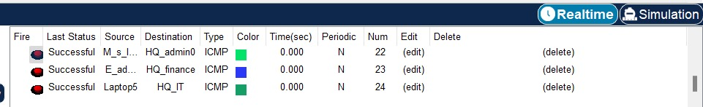Traffic Simulation: Packet Tracer allows the simulation of network traffic and communication between devices. This involves generating traffic, testing connectivity, and ensuring that data flows as expected.
* Verification of Redundancy and Failover: The hierarchical design with redundancy at every layer, including routers, multiple multilayer switches, was tested to verify failover mechanisms and ensure network resilience.

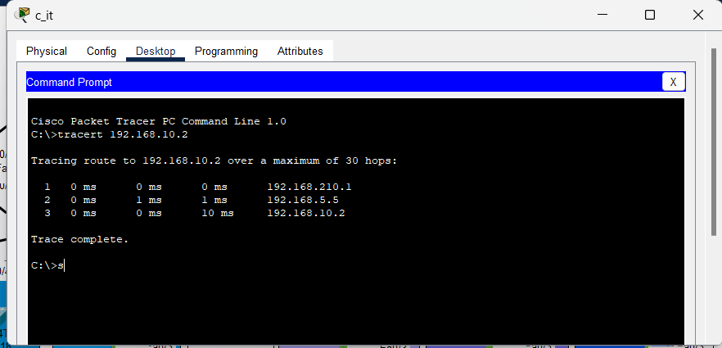

* DHCP and IP Address Allocation: Dynamic Host Configuration Protocol (DHCP) functionality and IP address allocation were tested to ensure that devices received the correct IP addresses dynamically and that devices in the server room had static IP assignments.

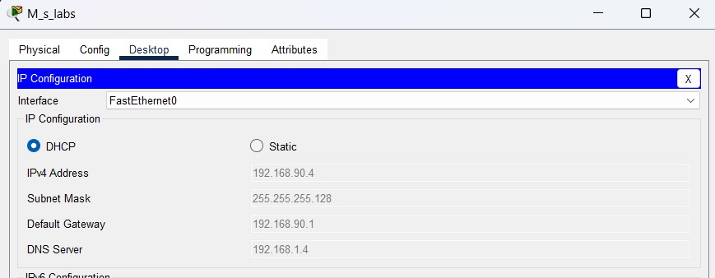

* E-mail server :  A mail server (sometimes called an email server) is a software program that sends and receives email.

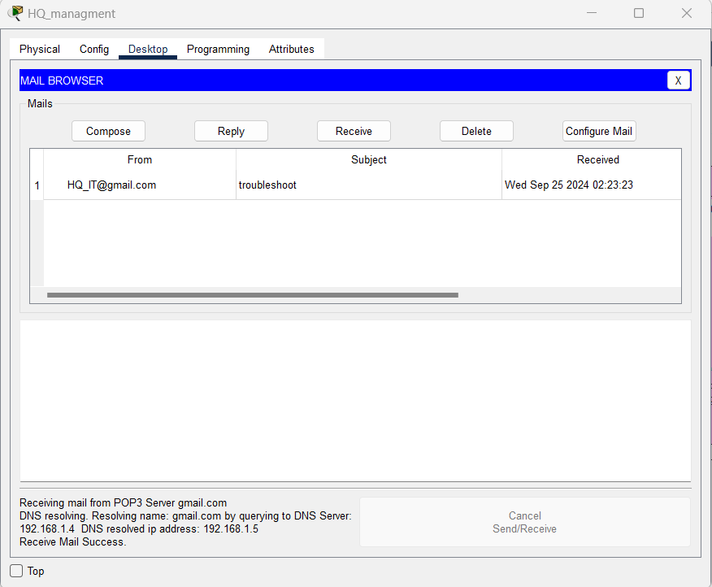

# Troubleshooting

During the testing phase, several common troubleshooting steps were taken to address issues:

* Device Connectivity: Ensured that all devices could communicate within their respective VLANs and across different departments. Verified inter-VLAN routing configurations on multilayer switches.
* DHCP Issues: Investigated and resolved any DHCP-related issues, ensuring that DHCP servers were reachable and capable of assigning IP addresses to devices dynamically.
* Routing Configuration: Verified the Border Gateway Protocol (BGP) routing configurations on routers and multilayer switches, ensuring proper routing table updates and communication between different departments.

# Results and Evaluation

* Performance Metrics

Performance metrics, including network latency, throughput, redundancy testing, DHCP response time, inter-VLAN routing performance, security, and NAT functionality, were measured during testing to ensure optimal network operation.

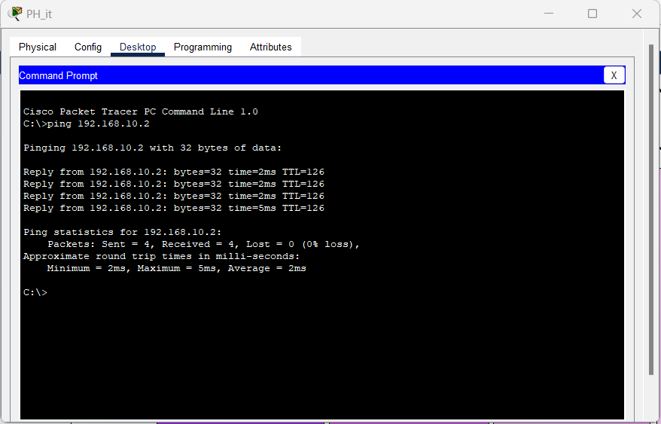

# Achievement of Objectives

* Redundancy:

1. multilayer switches

* Departmental Segmentation:

1. VLANs for enhanced security and organization.

* Inter-VLAN Routing:

1. Configured on multilayer switches.

* Security Measures:

1. ACLs, port-security, SSH for access control, VPN.

* NAT Configurations:

1. Effective private-to-public IP address translation.

* Thorough Testing:

1. Ensured proper functionality and adherence to requirements.

# Conclusion

In summary, the network design and implementation for the University network design have been successfully executed. Key achievements include a hierarchical network model with redundancy at multiple layers, departmental segmentation through VLANs, inter-VLAN routing, robust security measures, effective NAT, VPN configurations. Thorough testing using Cisco Packet Tracer ensured proper functionality and alignment with project requirements. The resulting network provides scalability, security, and efficiency, meeting the specified needs of the organization.